TASK 4 – WAN Technologies

- Create a comparison table listing at least 4 key differences between RADIUS and TACACS+ features, focusing on protocol type, encryption, ports used, and command authorization.
Ans.
Feature | RADIUS | TACACS+
Protocol Type | Open standard protocol commonly used for network access authentication. | Cisco-developed protocol mainly used for device administration and management.
Encryption | Encrypts only the user password in the authentication packet. | Encrypts the entire packet, providing better security.
Ports Used | Uses UDP ports 1812 (Authentication) and 1813 (Accounting). | Uses TCP port 49 for all AAA functions.
Command Authorization | Provides limited command authorization capabilities. | Supports detailed command-by-command authorization.
Reliability | Uses UDP, which is connectionless and less reliable. | Uses TCP, which is connection-oriented and more reliable.
AAA Functions | Combines Authentication and Authorization processes. | Separates Authentication, Authorization, and Accounting functions.

Explanation -
- RADIUS and TACACS+ are widely used AAA (Authentication, Authorization, and Accounting) protocols for securing network access. RADIUS is commonly used for user authentication in Wi-Fi, VPN, and remote access networks. It uses UDP ports 1812 and 1813 and encrypts only the user's password during authentication.
- TACACS+ is mainly used for managing and securing network devices such as routers and switches. It uses TCP port 49 and encrypts the entire packet, providing stronger security. TACACS+ also supports command-by-command authorization, allowing administrators to control exactly which commands a user can execute on a network device.

- Draw a simple flowchart or sequence diagram that illustrates the RADIUS authentication process for a user trying to log in to a Wi-Fi network (like at a coffee shop or college campus).
Ans.

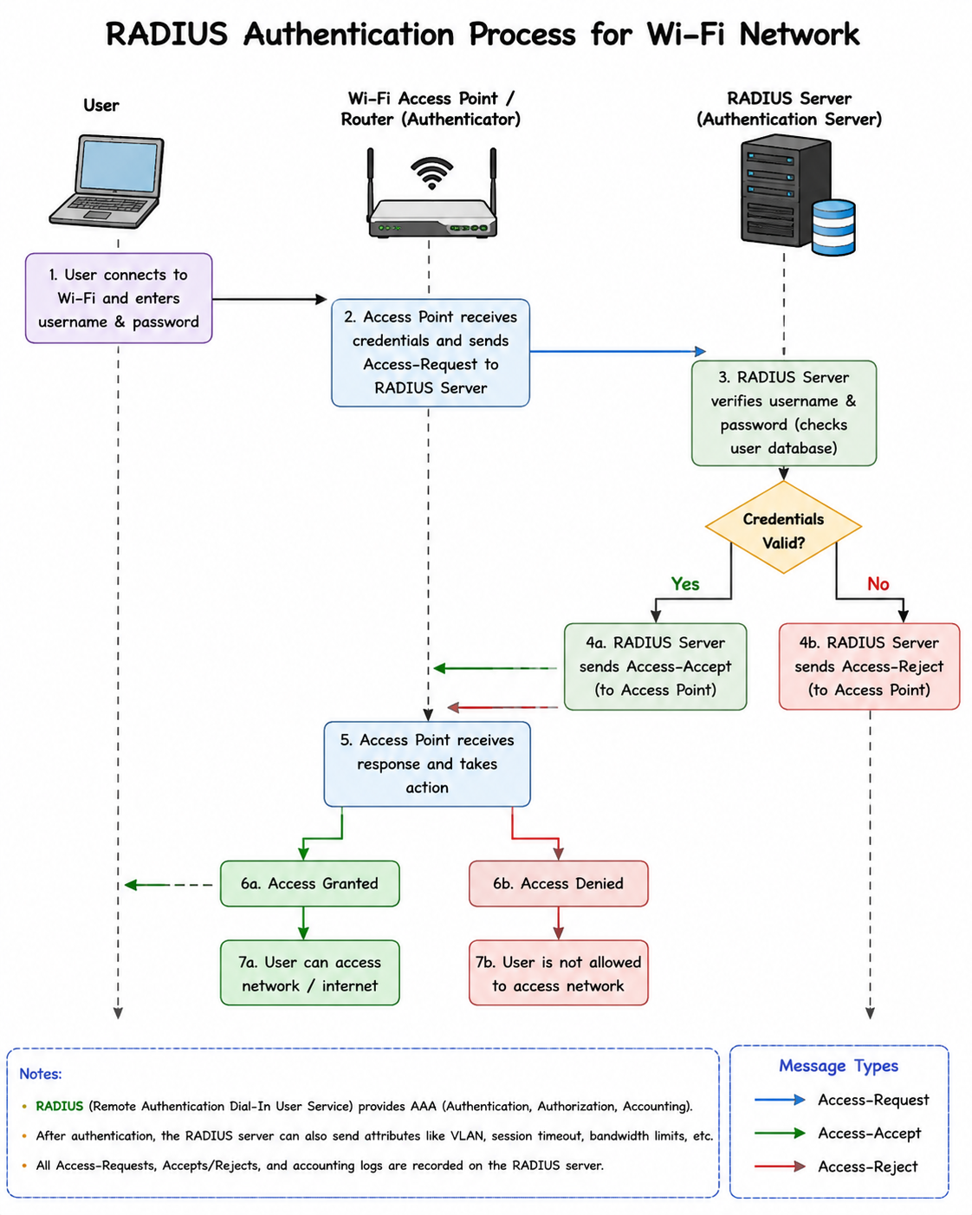

- Describe a real-world scenario from any app you use (such as Zomato, Paytm, or IRCTC) where TACACS+ would be more suitable than RADIUS for managing admin access, and explain why.
Ans.
Real-World Scenario: Paytm Admin Access Management
- Paytm handles millions of customer transactions every day. Network administrators and IT engineers need access to routers, switches, firewalls, and servers to manage and maintain the network infrastructure.
- In this situation, TACACS+ is more suitable than RADIUS because it provides command-by-command authorization. For example, a junior network administrator may be allowed to view device configurations but not allowed to make changes, while a senior administrator may have full access to configure network devices.
Why TACACS+ is Better in This Scenario
- It provides detailed control over administrator actions.
- It supports command-by-command authorization.
- It encrypts the entire communication packet, offering better security.
- It keeps detailed logs of every command executed by administrators.
Example
A Paytm network administrator logs into a router to troubleshoot a network issue. TACACS+ verifies the administrator's identity, checks which commands they are authorized to run, and records every action performed on the device. This helps prevent unauthorized changes and improves security and accountability.

- List two advantages and two disadvantages of using RADIUS for network authentication in a public hotspot (like those found in malls or airports).
Ans.
Advantages of Using RADIUS in a Public Hotspot

1. Centralized Authentication: RADIUS allows user accounts to be managed from a central server, making administration easier.
2. Supports AAA Services: RADIUS provides Authentication, Authorization, and Accounting, helping track user logins and internet usage.

Disadvantages of Using RADIUS in a Public Hotspot

1. Limited Encryption: RADIUS encrypts only the user password, not the entire packet, which provides less security than TACACS+.
2. Uses UDP: Since RADIUS uses UDP, it is connectionless and may be less reliable than TCP-based protocols.

- Use ChatGPT or another AI tool to generate a sample TACACS+ configuration for a Cisco router, then review the output and highlight any commands you would modify for a college lab setup.<br><br><em><strong>.
Ans. 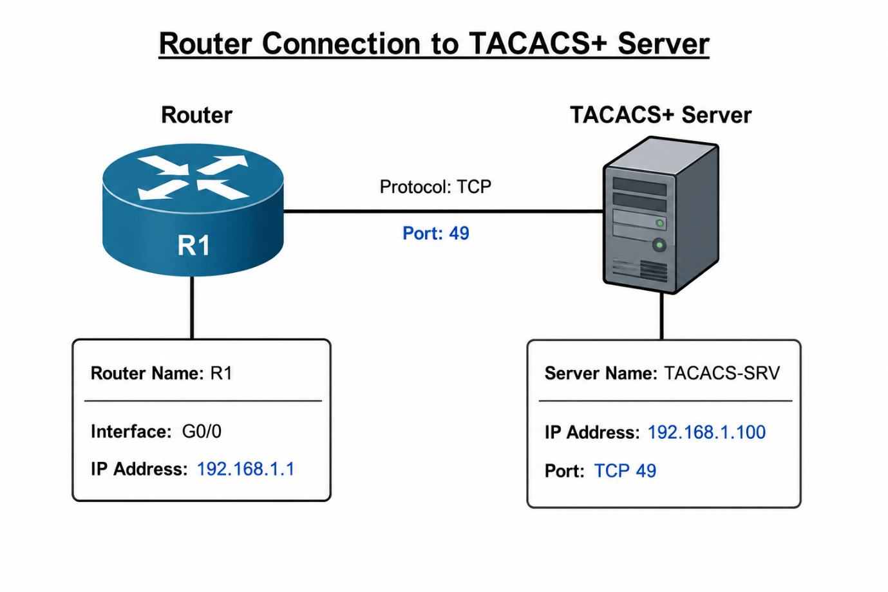
Router> enable
Router# configure terminal

Router(config)# aaa new-model

Router(config)# tacacs-server host 192.168.1.100
Router(config)# tacacs-server key cisco123

Router(config)# aaa authentication login default group tacacs+ local
Router(config)# aaa authorization exec default group tacacs+ local

Router(config)# line vty 0 4
Router(config-line)# login authentication default
Router(config-line)# transport input telnet ssh

Router(config)# end
Router# write memory

Original Command | Modified Command | Reason
tacacs-server host 192.168.1.100 | tacacs-server host 10.0.0.10 | Use the IP address assigned to the TACACS+ server in the lab.
tacacs-server key cisco123 | tacacs-server key lab123 | Use a simple lab password chosen by the instructor.
transport input telnet ssh | transport input ssh | SSH is more secure than Telnet.
aaa authentication login default group tacacs+ local | Keep the same | Allows backup local login if the TACACS+ server is unavailable.

Explanation -

- The command aaa new-model enables AAA services on the router. The tacacs-server host command specifies the TACACS+ server IP address, and tacacs-server key configures the shared secret key used for communication. Authentication and authorization are then configured to use the TACACS+ server.

- For a college lab, the TACACS+ server IP address and key should be changed to match the lab environment. Using SSH instead of Telnet is recommended because SSH encrypts the connection and provides better security.

